**safeguarding in our Parish**

CONTACT The Diocesan Designated Liaison Person,

Ms. Kathleen Sherry, 085 802 1633 - [dlp@ossory.ie](mailto:dlp@ossory.ie)

OUR PARISH SAFEGUARDING REPRESENTATIVE:

Sr Betty Cagney

Counselling Services - Towards Healing Confidential Helpline 1800 313 316 – [www.towardshealing.ie](http://www.towardshealing.ie/)

Towards Healing is an independent organization, funded by the Catholic Church, providing professional support for people who have experienced institutional, clerical or religious abuse in Ireland. Towards Healing offers a range of counselling and support services: Face-to-Face Counselling; Friendly Call; Structured Telephone; Counselling; Family Counselling

**Benedict…may your joy be complete**

Excerpt from Pope Francis’ Homily:

*Holding fast to the Lord’s last words and to the witness of his entire life, we too, as an ecclesial community, want to follow in his steps and to commend our brother into the hands of the Father. May those merciful hands find his lamp alight with the oil of the Gospel that he spread and testified to for his entire life (cf. Mt 25:6-7).*

*…God’s faithful people, gathered here, now accompanies and entrusts to him the life of the one who was their pastor. Like the women at the tomb, we too have come with the fragrance of gratitude and the balm of hope, in order to show him once more the love that is undying. We want to do this with the same wisdom, tenderness, and devotion that he bestowed upon us over the years. Together, we want to say: “Father, into your hands we commend his spirit.”*

*Benedict, faithful friend of the Bridegroom, may your joy be complete as you hear his voice, now and forever!*

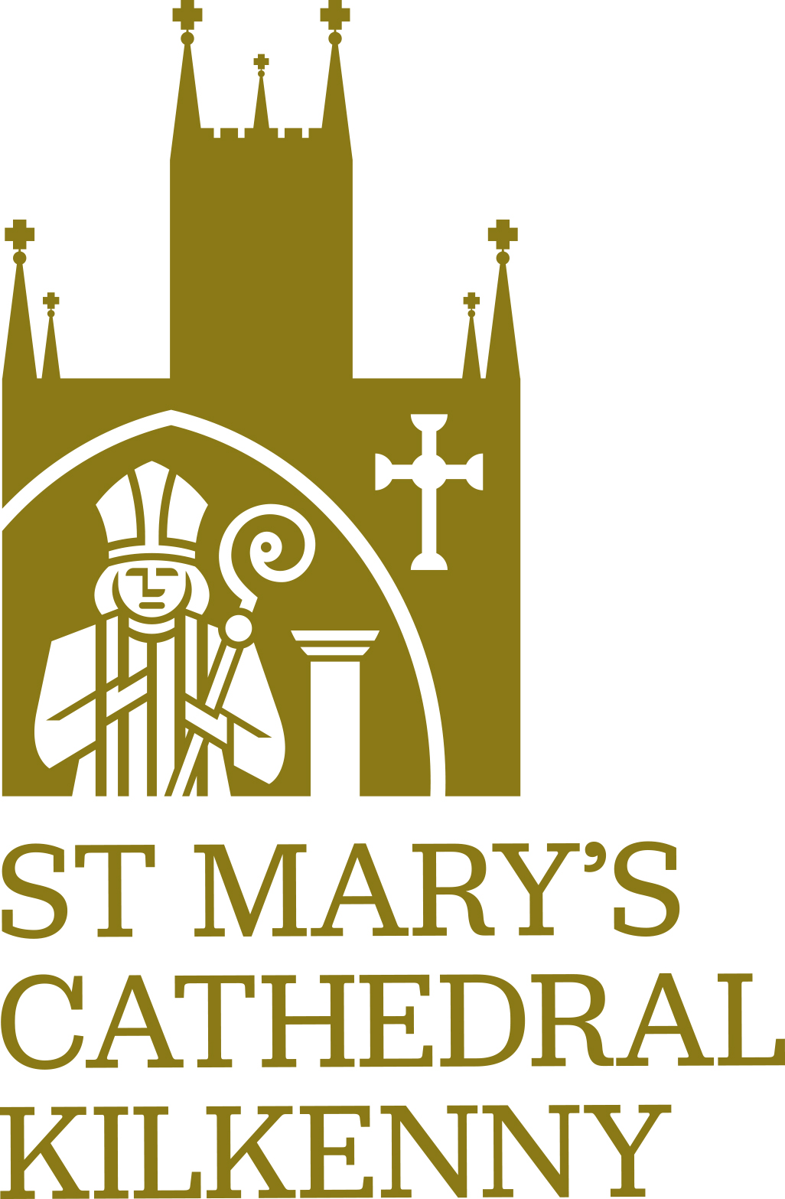******

**Episcopal Ordination of Fr Niall Coll**

The ordination of Fr Niall Coll as Bishop of Ossory will take place on January 22nd at 3pm in St Mary’s Cathedral. The ordaining bishop will be Archbishop Dermot Farrell, Archbishop of Dublin.

Attendance at the ordination will be by ticket only; a limited number of tickets are available to the parish for the ceremony on that day. Please contact the office to indicate your interest in attending.

There will be a choir practice this afternoon and again next Sunday in the Cathedral in preparation. It is anticipated that the choir will be 100 singers from various parishes in the diocese.

A group of 15 musicians from around the diocese are also preparing for the ceremony.

On Friday 20th January there will be a ceremony, led by Bishop Nulty, during which Fr Coll’s Episcopal ring, Mitre and Crozier will be blessed.

A group of young people, mainly Transition Year and 5th year students, in our schools have been invited to serve at the ordination mass. This team will be prepared by Fr Scriven and Fr Whearty and will be available on a ongoing basis to serve at ceremonies in the Cathedral.

**Ongoing Works in the Cathedral**

Before Christmas the kneelers of the pews in the central aisle were replaced and the reaction has been very positive. It is hope, funds permitting, to continue this restoration work in the remainder of this cathedral this year.

During this coming week work will commence on the windows in the Triforium. This is the area above the two side aisles in the main body of the church. There are no shutters or glass in the majority of these windows and the plan this week is to close these openings with insulated board. It is anticipated that this work will assist in reducing air flow and breezes in the cathedral and help the overall ambient heat in the cathedral.

Work will also be undertaken in the grounds of the cathedral on the north side, between the cathedral and chapter house. There is long term more permanent plan for this area, and this will be presented to the bishop in the coming months for his consideration.

Cleaners have also been contracted to do an overall clean of the cathedral on the completion of the work.

**BECOME A FRIEND OF ST MARY’S CATHEDRAL**

**St. Mary’s Cathedral**

**8th January 2023**

**The Baptism of the Lord**

**Please remember the following in your prayers**

**Recently deceased**

Elizabeth (Betty) Davin, St. Francis Terrace

Dermot Brophy, Riverview

**Months Mind**

11am: Rita O’Brien, Dean Cavanagh Place

11am: Sean Hayes, Dean Cavanagh Place.

5.30pm: Eileen Lennon

**Anniversaries**

Lorenzo Mahony, Margaret Doran, Patrick Doran, Catherine Delaney, Michael Delaney.

**Masses during this coming week.**

Please note there will be no 9am mass in the Cathedral Monday to Thursday of this coming week. Mass will be celebrated on Friday and Saturday morning.

**Access to the Cathedral**

For health and safety reasons access to the cathedral during the works of this coming week will be through the side door only – the centre aisle of the church will be restricted to authorised workers only..

**Book of condolence**

A book of condolence is in the cathedral and you are invited to sign on the occasion of the passing of Pope Emeritus Benedict XVI. The book will be presented to the Papal Nuncio’s Representative when he visits St Mary’s Cathedral on the 22nd when he will attend the ordination of Fr Coll as Bishop of Ossory.

**Cathedral Gift Shop**

The Shop will re-open on Tuesday January 10th. A wide range of gifts, books and religious items available.

**The Cathedral Crib**

The crib will remain in place until Friday of this week -= the 13th January. The figures which have been much admired will be stored safely – it is believed that these figures date to 1933: 90 years this year.

[**www.stmaryscathedal.ie**](http://www.stmaryscathedal.ie)